Welfare collaboration in Norway: Something old, something new, something borrowed, something to pursue?

**The Ph.D. Project**

Employed at the Western Norway University of Applied Sciences

Ph.D. University of Bergen

Supervisor Prof. Jacob Aars

**Background/motivation**

In recent years, modern welfare states have faced growing demands for public sector innovation. These growing demands can be seen as a response to a rise in citizen’s expectations, new societal and policy challenges, and dire fiscal constraints. As a result, new forms of multi-actor collaboration have emerged as global ideas for how to innovate the public sector.

Global ideas are operationalized as new forms of collaboration and the selected new forms of collaborations are social enterprise and a collaborative innovation project. Both phenomena can be considered good examples of new forms of collaboration as they can stimulate new cross-sectoral actions between partners holding different institutional logics contributing with different resources in arranging welfare services, on the one hand. Yet, on the other, they may also pose as highly ambiguous for the modern welfare state as they can create tension among actors, organizations, sectors, and institutions.

The research problem raised in this thesis is

*How are global ideas adapted by modern welfare states? And, how might welfare state models affect the adaptation?*

I have focused on how global ideas are adapted in the Nordic welfare model, represented by the study context of Norway. The reason for this, is because inherent in this model lie two competing legacies both of which are likely to affect how these new forms of collaborations are adapted in the policy field of welfare provision. On the one hand, the Nordic countries have a legacy of cooperation between public and voluntary organizations concerning the production of welfare. This legacy suggests that there may already exist willingness in the Nordic countries to (re-)adapt to collaborative efforts. On the other, the Nordic welfare model has a legacy of statism, where the state took over for most of the multi-actor cooperation and the provision of welfare in the post-war years. The Nordic countries are still characterized as “state friendly” and still have large public sectors delivering universal welfare services with less reliance on private and voluntary efforts in providing welfare. This may suggest that there is a lack of pressure or willingness to adapt these new forms of collaboration in the policy field of welfare provision.

I have employed a complementary analytical approach (Roness, 1997: 89) that studies the adaptation of new forms of collaboration from three analytical levels, namely a *policy*, a *field* and an *applied* level. The thesis explores FIRST, how policymakers adapt new forms of collaboration by way of policy making; SECOND, how new forms of collaborations are adapted in the policy field of welfare provision, and THIRD, how new forms of collaboration are adapted in local public sector organizations.

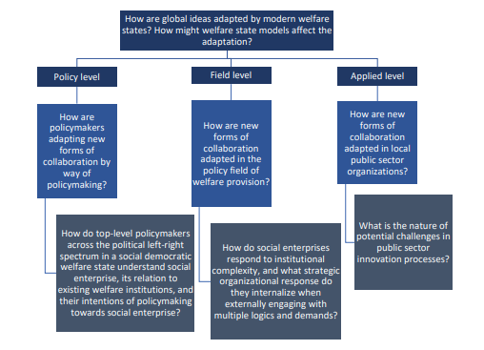

The thesis consists of three research papers, all published in their subsequent journals.

**Theoretical framework**

I will now present the theoretical framework employed in this thesis.

I have used a neo-institutionalist theoretical approach as the overarching theoretical framework tying the three research articles together. This framework emphasizes contextual features and has thus allowed me to explore contextual features of the Nordic context, its legacies of cooperation and statism, its reform trends as well as how different actors at the three analytical levels adapt these new ways of collaborating. Here I have relied on the Scandinavian institutionalist theory on translation, however, I have coupled this stance, with the more actor-focused stance of the translation perspective from the actor network-theoretical approach. I have also employed the theory of path dependence and gradual institutional change to understand and explain how global ideas operationalized as new forms of collaboration are shaped by the context.

**Methods**

As there lacks substantive empirical data in parts of the scope of my research, I have used an exploratory research design.

The primary data material collected and analyzed in this thesis includes semi-structured interviews. The choice of employing semi-structured interviews were both a strategic and pragmatical choice. It was strategic in the sense that it allowed me flexibility to follow the lines of inquiry introduced by what each of the informants said and it allowed the informants the freedom to express their views in their own terms – this was especially important in instances where the study object had strongly opposite views. And it was pragmatic in the sense that it is a recommended choice of method when studying a phenomenon lacking a well-developed understanding (Yin, 2018), and that it allowed me to validate or disprove information from the extant literature.

I conducted separate interviews for each of the articles. The informants were recruited strategically, and involved identifying and selecting individuals or groups of individuals that are especially knowledgeable or experienced with the phenomenon of interest, resembling that of purposeful sampling. The importance of availability and willingness to participate and the ability to communicate experiences and opinions were also vital criteria for the sampling process.

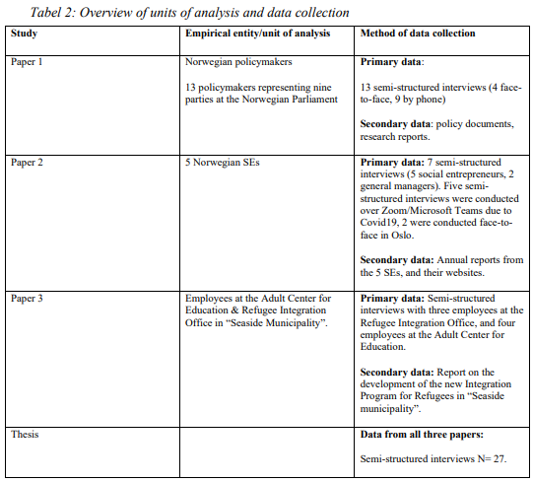

As you see, for paper one, 11 policymakers (including Parliament members and party members at the local and regional level) were recruited representing nine parties at the Norwegian Parliament. There were difficulties recruiting policymakers that had knowledge about social enterprises and that were willing and able to be interviewed. The secondary data included policy documents and research reports.

For the second paper, 7 semi-structured interviews with people pertaining to 5 social enterprises were recruited. These included 5 social entrepreneurs or founders of the social enterprises and 2 general managers.

For the third paper, a total of 7 informants were interviewed and included employees at the 2 public sector organizations collaborating on the innovation project.

The total amount of informants amounts to 25.

*Limitations – sample sizes in each article and data*

There are certain limitations related to the sample size in each article.

**Articles**

*Article 1*

Departing from the analytical level, the *policy* level, in article 1 I have studied how policymakers are adapting new forms of collaboration by way of policymaking. New forms of collaboration are in this article operationalized as social enterprise, and the type of policy studied here is a legal organizational form. The development of social enterprise in the Nordic countries is considered a typical case of policy diffusion, where concepts and models from another context are imported into the Nordic context. Policymaking is in this article understood as *action* or *inaction*. And I explore *why* policymakers in Norway has chosen inaction over action in policymaking in terms of an organizational form social enterprise. The article is written together with my co-author Hans Abraham Hauge, and it was published in the Social Enterprise Journal in 2023.

*Article 2*

In the second article, departing from the *field level of analysis,* also here, new forms of collaboration have been operationalized as social enterprise. The focus has been to explore and understand how social enterprises are adapted into the field of welfare provision. The research question focuses on how social enterprises respond to institutional complexity, and what strategic organizational response they internalize when externally engaging with multiple logics and demands. I have been the sole author on this article, and it was published in VOLUNTAS – International Journal of Voluntary and Nonprofit organizations in 2022.

*Article 3*

In the third and final article, at the *applied level of analysis,* the new form of collaboration was operationalized as a collaborative innovation project between two public sector organizations. The project entail developing and implementing a new Introduction Program for Refugees that employed a social enterprise as an integration vehicle. The raised research question in the article is *What is the nature of potential challenges facing public sector innovation processes?* The article was co-authored by Mai Camilla Munkejord and was published in the Nordic Journal of Social Research in 2021.

**Findings**

The overall findings from my thesis demonstrate in line with the extant literature that the adaptation of global ideas in new contexts is a complex process and it shows that the outcome of the adaptation process is in the hands of many actors and placed at different levels within modern welfare states.

The findings illustrate how institutional factors such as historical, cultural, and traditional trajectories in the Nordic welfare state model plays part in shaping how global ideas are adapted. I find that the layering of pervious reforms, path-dependent trajectory, the legacy of statism alongside market-inspired practices, ideologies, conflicting logics and perceptions plays important roles in the adaptation process.

More specifically, I find that the reason that policymakers opt for policy inaction (in terms of establishing a legal organizational form) is because they view social enterprise not as a new phenomenon in its own right, but instead in relation to the existing system for public procurement of welfare services meaning that they are viewed as potential providers of welfare services commissioned by the state. This can either (or both) reflect path dependency, *or* it can reflect a limited need for social enterprise in the highly institutionalized Norwegian system for welfare provision.

Second, the empirical data indicate that Norwegian social enterprises are highly dependent on the acceptance of institutional referents operating with a public-sector logic as these actors function as gatekeepers with regards to public grants, funding and support mechanisms. They are therefore pressured to emphasize their social mission which can sometimes compromise the economic dimension within the organization. However, Norwegian social enterprises select different strategies to secure compliance with internal and external logics. And while more research is needed to address this issue, it may seem that logic compartmentalization may be a pragmatic solutions for social enterprises as the data indicate that it may be easier to attend their mission while at the same time adhere to external demands.

Third, the data indicate that when developing and implementing new forms of collaboration across organizational boundaries, it is important for the innovation process to be openly discussed, and to agree on what “collaboration” means in a project. And when tensions emerge, it is crucial to address and clarify *why* the innovation is being realized, *how* to operationalize such innovations, for *whom* the innovation is targeted, and *whose* project it is. The data also show that it is important for the implementation of an innovative collaboration project that the project leader create and implement clear structures for collaboration including relevant actors in important decisions.

**Contributions to the field**

The contributions of this thesis are of an empirical, practical, and theoretical nature.

The research topic of social enterprise is small in scope in the Norwegian context, and the research that is published has often been on theoretical and conceptual discussions of the SE field in Norway. Therefore, this thesis contributes with *empirical knowledge* when studying the adaptation of global ideas in the Nordic context. For example, it contributes with knowledge about how actors with the power to strengthen the social enterprise ecosystem understand these types of organizations. Empirically, it also contributes with knowledge about how social enterprises manage institutional complexity in the Nordic welfare state. In comparative research projects on social enterprise, this thesis also contributes to further develop existing empirical frameworks with more knowledge form the Nordic region.

This thesis also contributes with practical contributions for practitioners as it highlights important features that can help avoid – or at least – help address tensions collaborative innovation projects between two public sector organizations.

The thesis also has some theoretical contributions in relation to *combining* the French sociologist actor-network-theory with the Scandinavian institutionalist approach of translation theory. It also contributes with a possible theoretical *expansion* of the theory of institutional logics.

Thank you for your attention.