Lecture Wednesday 29 August 2007 ( updated 30.08.2007 version)
Topics: Helium atom part 1 - Intro and mainly so called symmetry
Classical schematics of He-like atom – nucleus +Ze + 2 e⁻
other 2-electron atoms H⁻ He Li⁺ Be⁺⁺ B⁺⁺⁺ C⁴⁺
1- electron sequence H He⁺ Li⁺⁺ Be⁺⁺⁺ B⁴⁺ C⁵⁺ ...... U⁹¹⁺
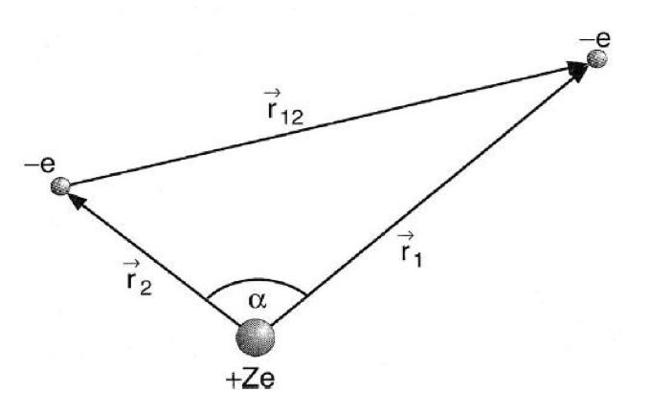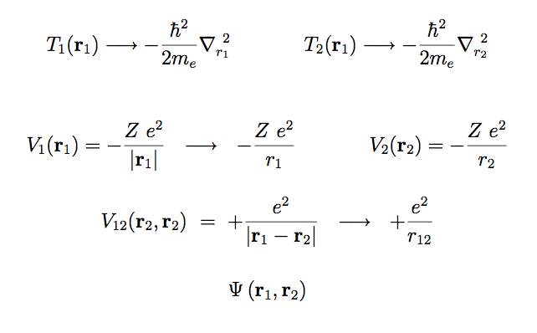
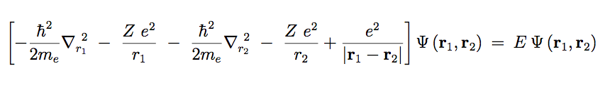
Independent electrons wavefunction: it reflects the probability of independent events, which is a product of probabilities. (the coins throwing etc – independent results). When events are dependent – conditional probabolities – not product
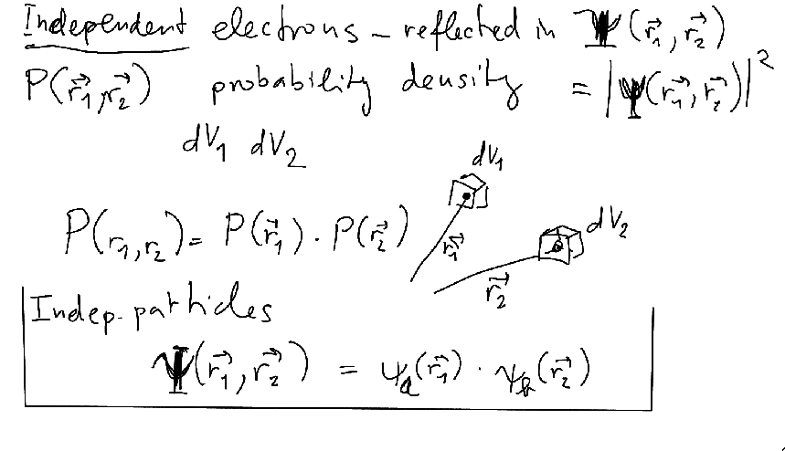

We will now look at the origin of «Symmetry» Historically – Pauli Principle – and the «Aufbau Principle»
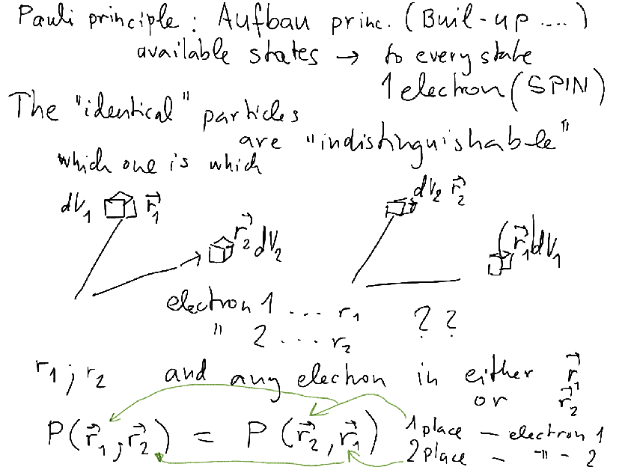
Whether dependent or not, the exchange, or replacement (Norwegian: ombytting German Vertauschung ... French ... la symétrie d’échange....) should not change the probability distributions whn the electrons are «just the same» - i.e. impossible to distinguish between them – or identical ... it has a «touch of observation».....
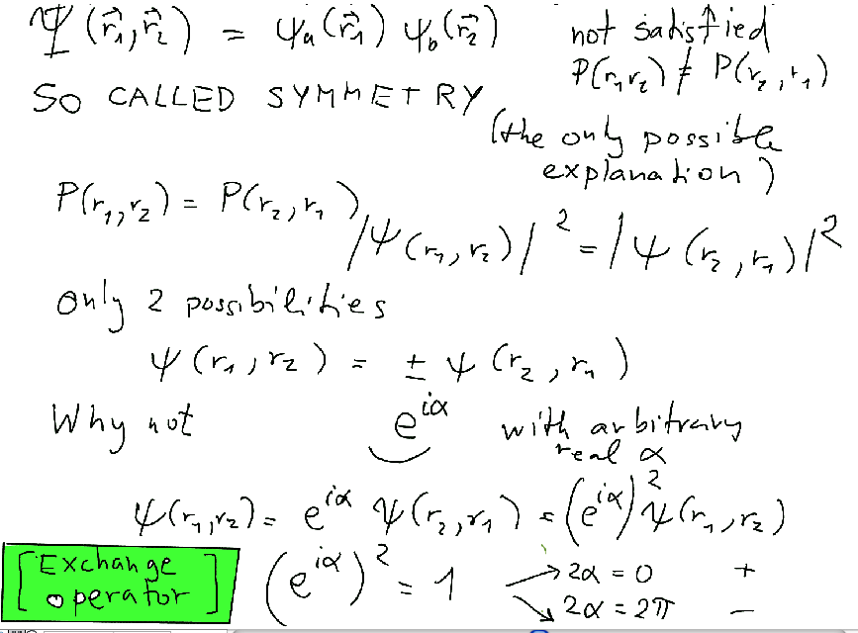
Simple «ombytting» or exchange of coordinates can be replaced by mathematical operator – mathematical formalism – EXCHANGE OPERATOR
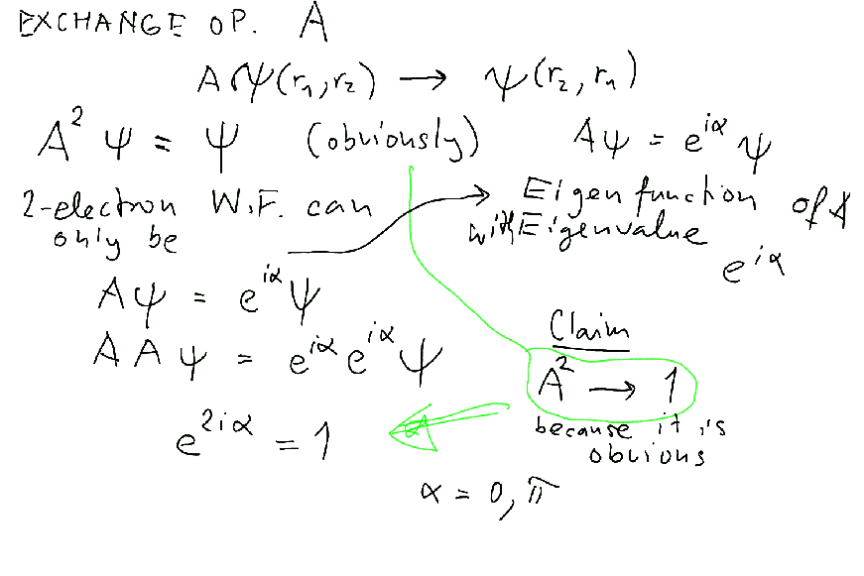

Funny that it can not be any phase – we can understand the mathematical formulation of saying that the wavefunctions must be eigenstates of exchange,
the e ^{i α} is an eigenvalue ...
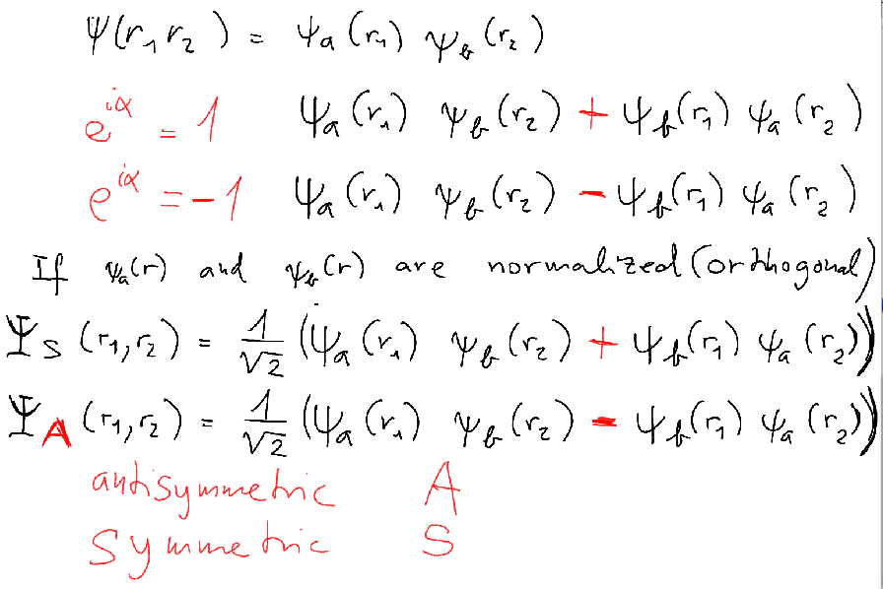
History of spin – Pauli – but «invented» before Pauli – Zeeman effect etc
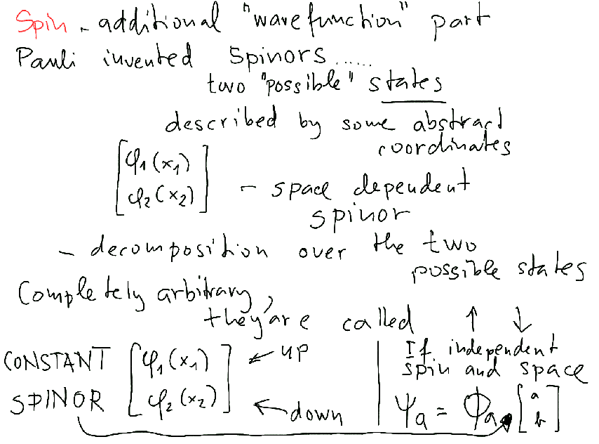

Homework: show that they are the same functions
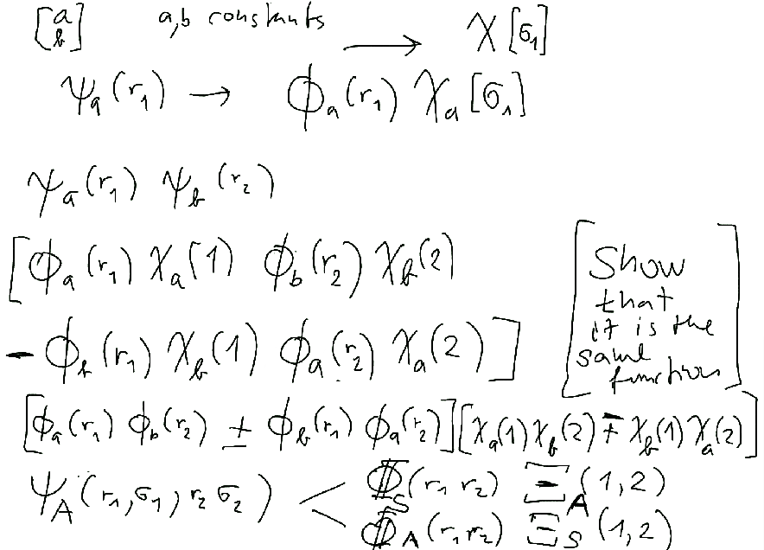

About Ions and hydrogen-like atoms.... beginning of lecture
This belongs to the Hydrogen Atom Reviews

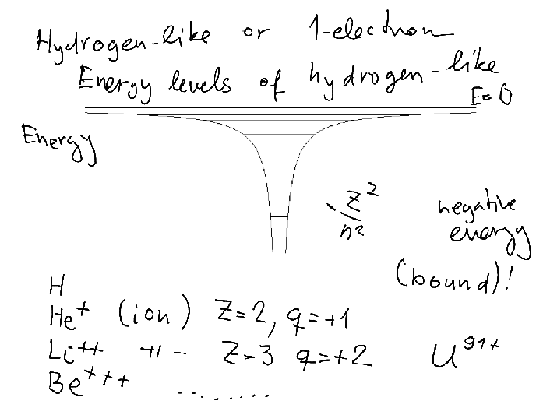

1- electron sequence H He⁺ Li⁺⁺ Be⁺⁺⁺ B⁴⁺ C⁵⁺ ...... U⁹¹⁺

