Lecture Wednesday 5 September 2007
Topics Helium part 3: Ground State; Independent electrons; ( Variational Method next)
Bound states – energies – and Helium; Classically unstable
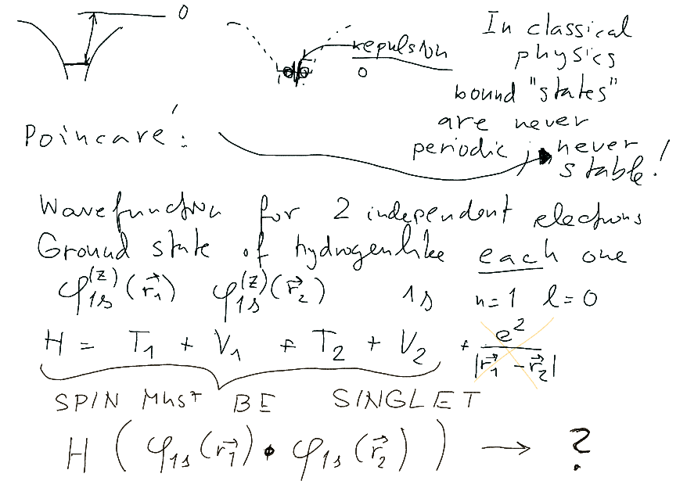
Independent particles - energies
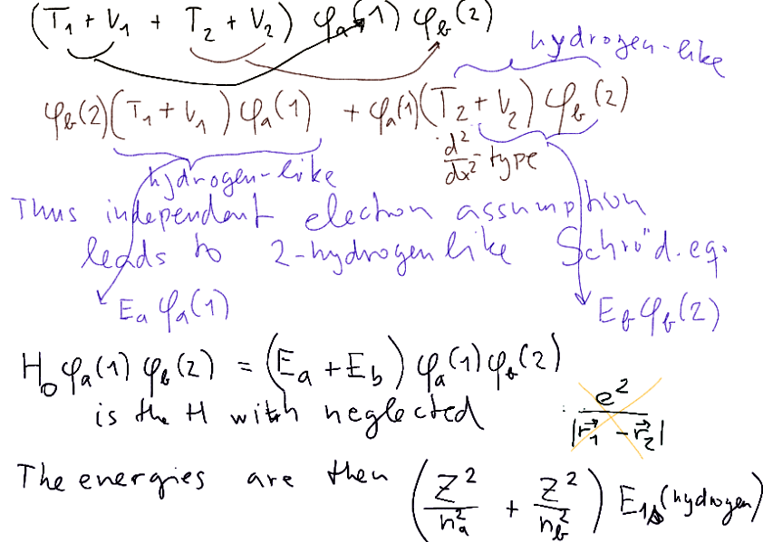

Experiment etc ....
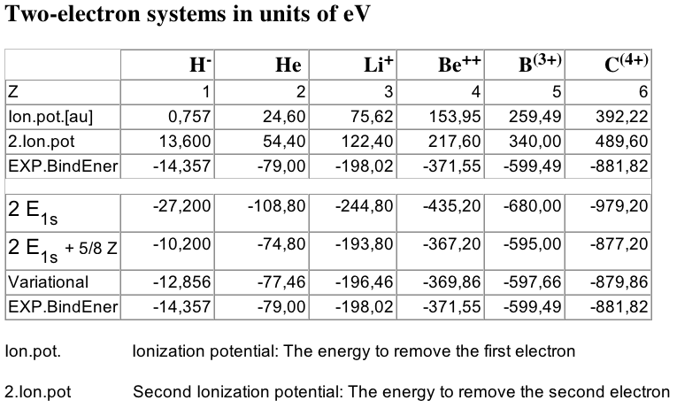
Evaluate expectation value – What is expectation value ?
Example – age distribution – average value of age
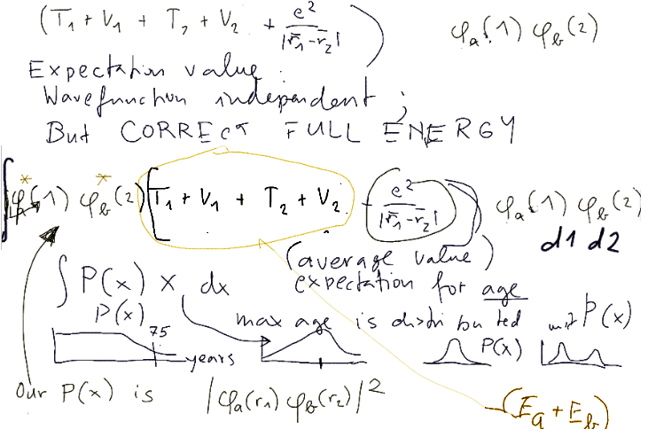

Generally for any two states a,b - but we specify a->1s b->1s; Multipole expansion
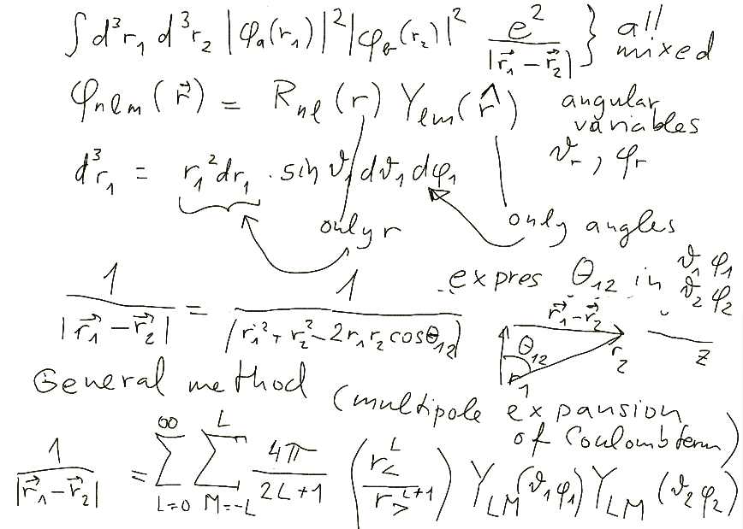

How to perform the 6-dim integration: two angular (4 dimensions) using Y – spherical harmonics

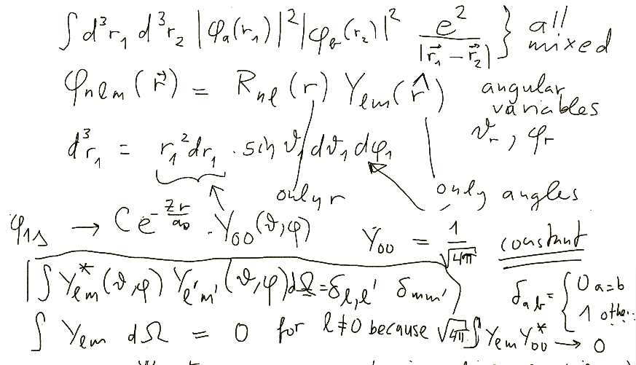
Orthogonality of spherical harmonics

Gives that the integral of one Y is zero (unless L=0....)
The evaluation reduces to a two-dimensional integral over r₁ and r₂ (with r> )
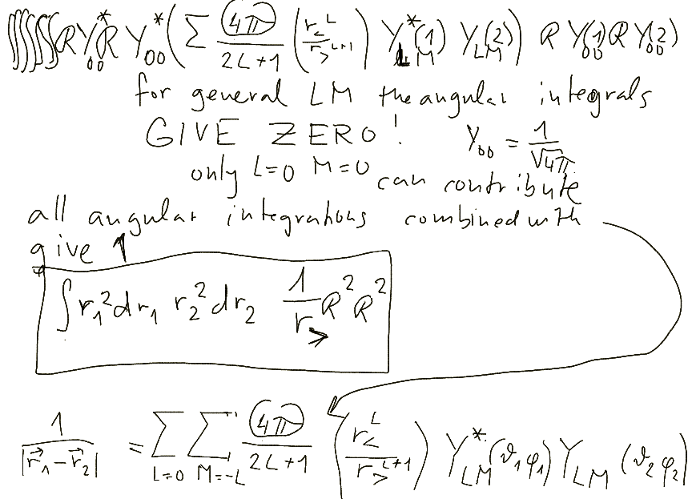
We must evaluate the integrals
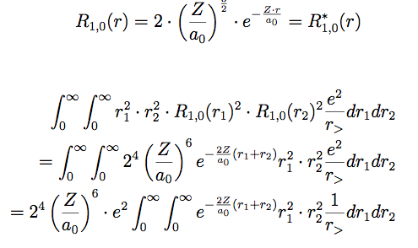
The r> must be replaced .... which leads to two integrations
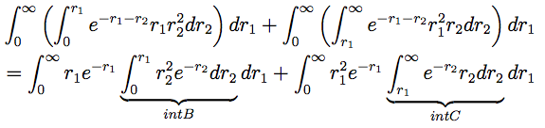
And the result is .....
< | V12 | > -> 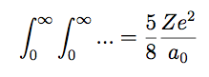

And the result is .....
< | V12 | > ->

The multipole expansion we used:



