Lecture Thursday 13. September 2007
Topics: Many.elecron atoms part 1
Comment ...
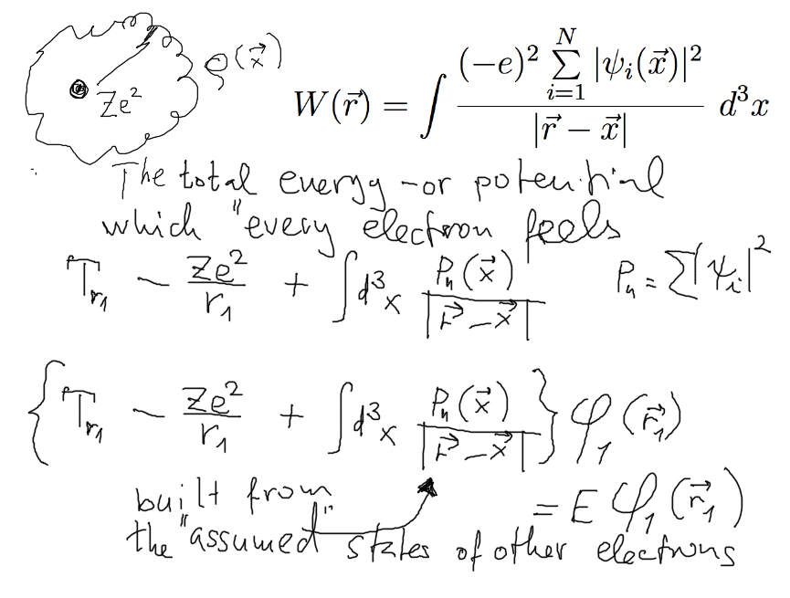
Comment
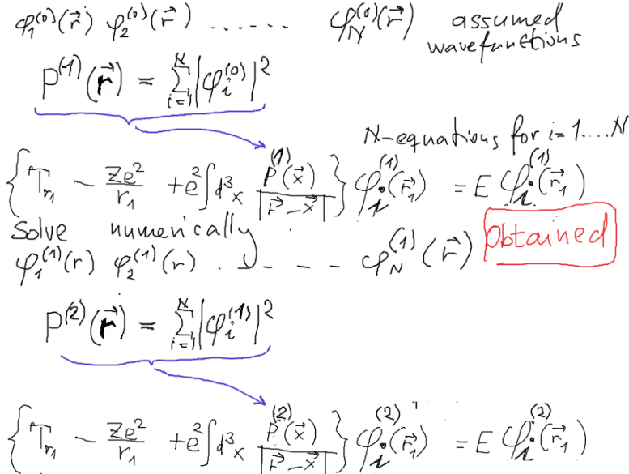

Comment
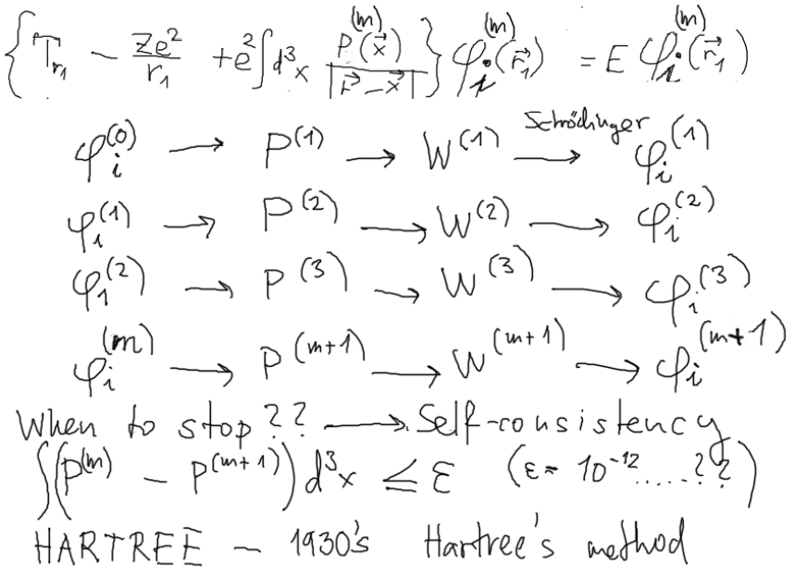
What we should know:
2s 2p have the same energy in H and H-like
3s 3p 3d have the same energy in H and H-like
4s 4p 4d 4f have the same energy in H and H-like

in screened potential
2s comes under 2p
3s comes under 3p which is under 3d

for Argon and transition to Sodium
4s comes deep under 3d etc etc
Exercise on Qualitative SCF

The n,l states sequence in SCF potential
is influenced by the centrifugal barrier

Comment
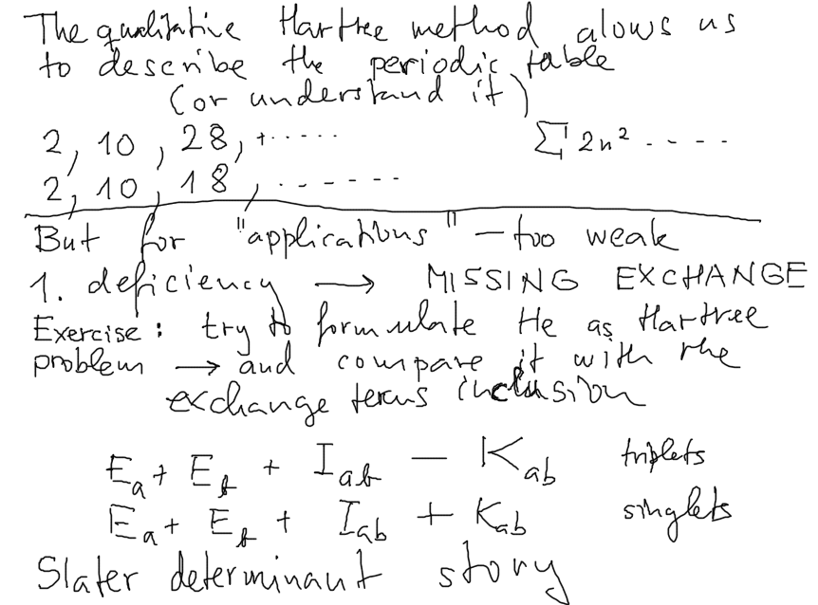
2 particles – simple – determinant – generalize for many
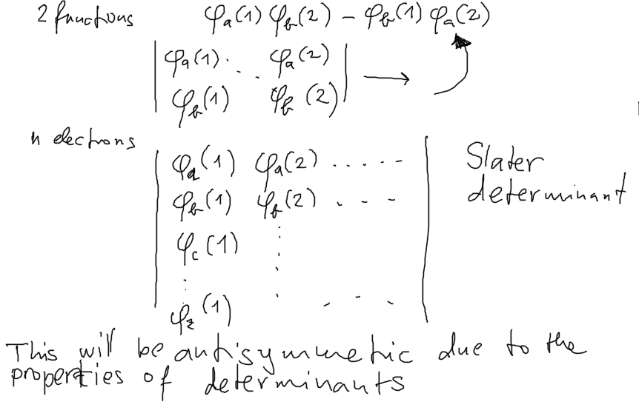

For Lithium ... Z=3
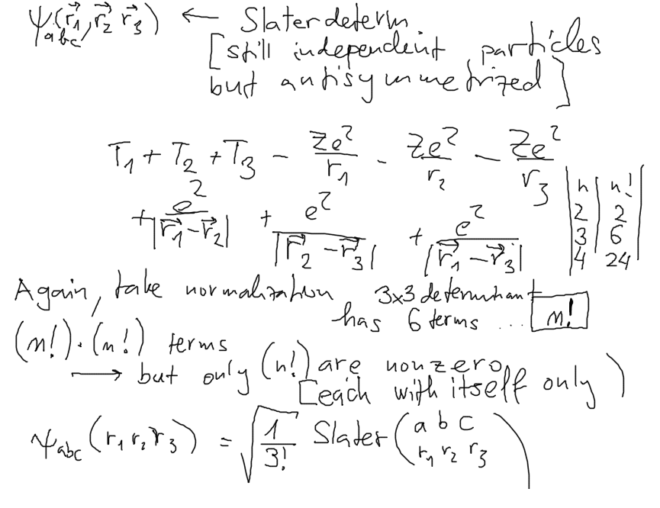
single particle operators give all just ONE from n!

From 2006 work
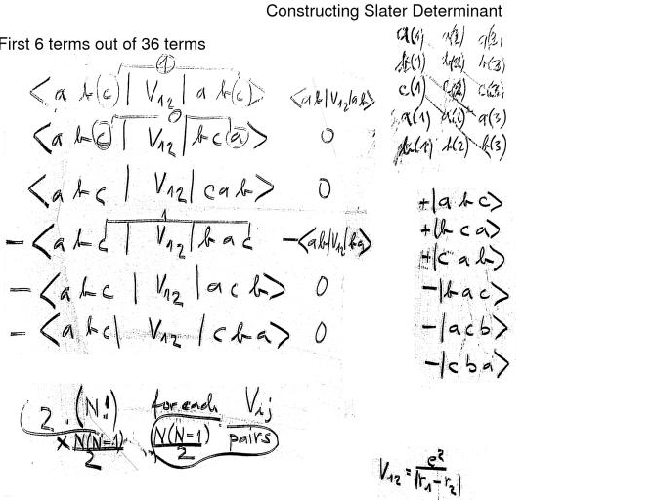

Comment
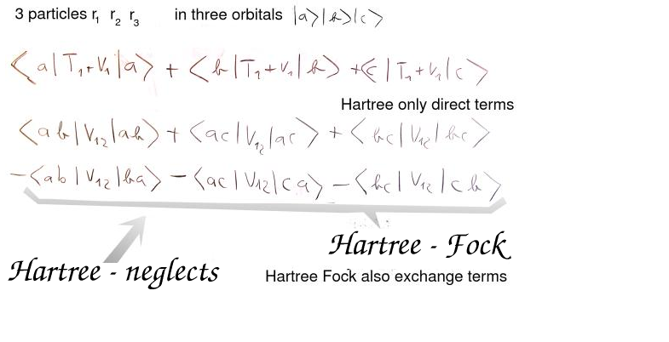

Sum over pairs of coordinates --> Sum over pairs of orbitals (wavefunctions)



