Lecture Wednesday 19. September 2007
Topics:
Hartree-Fock Method, Variational method
Lagrange Multipliers special addition

Comments
The missing last slide corrected (after the lecture, 20.09.2007)
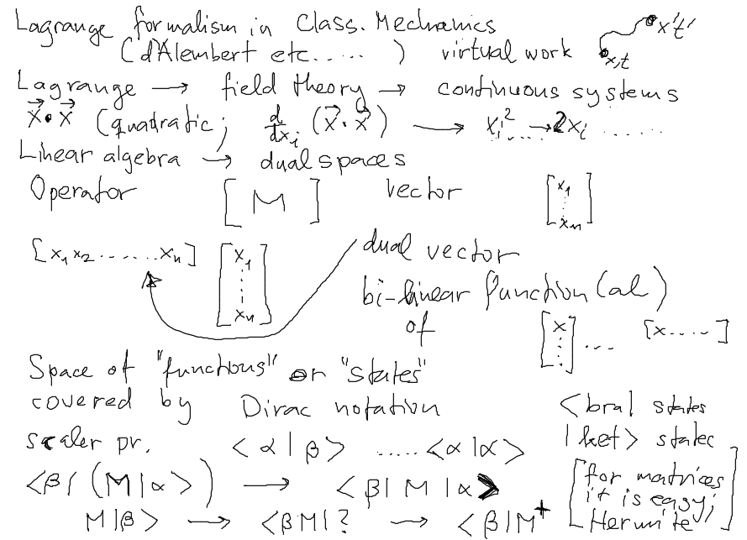
Lagrange Formalism; Virtual Work; Linear ALgebra and all that
Dirac Notation
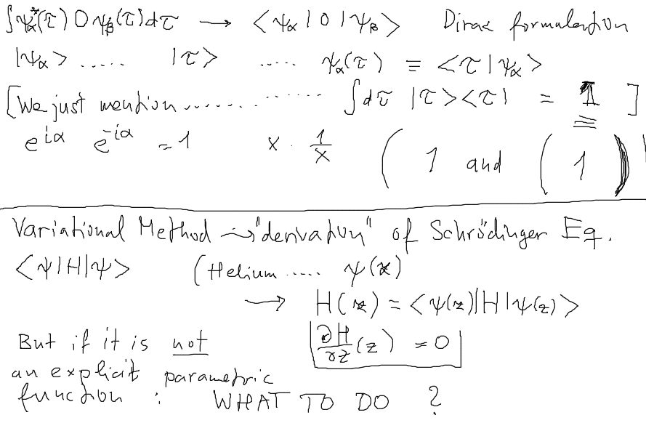
Variational ... How to get general Schr. Eq.

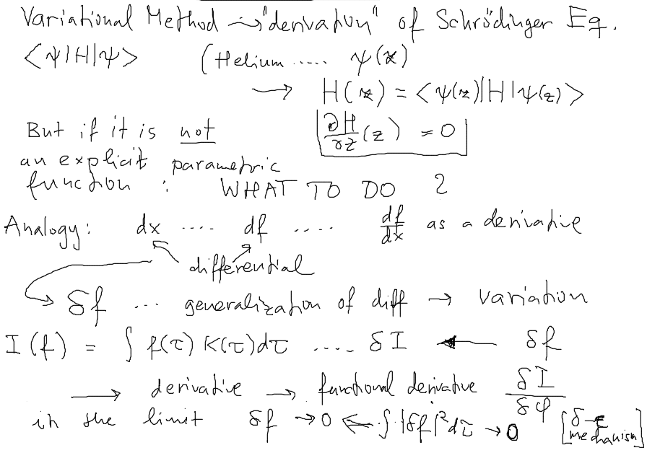
Start Again – How to get it?
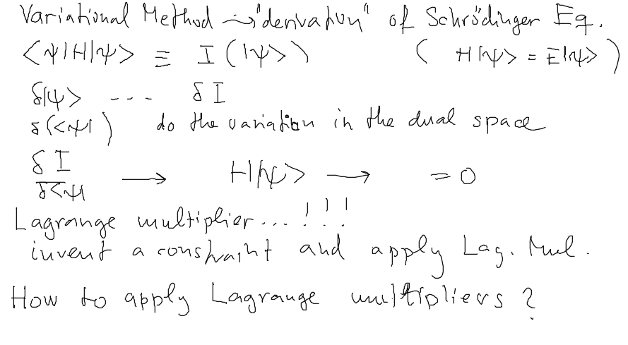

Lagrange Multipliers Part 1
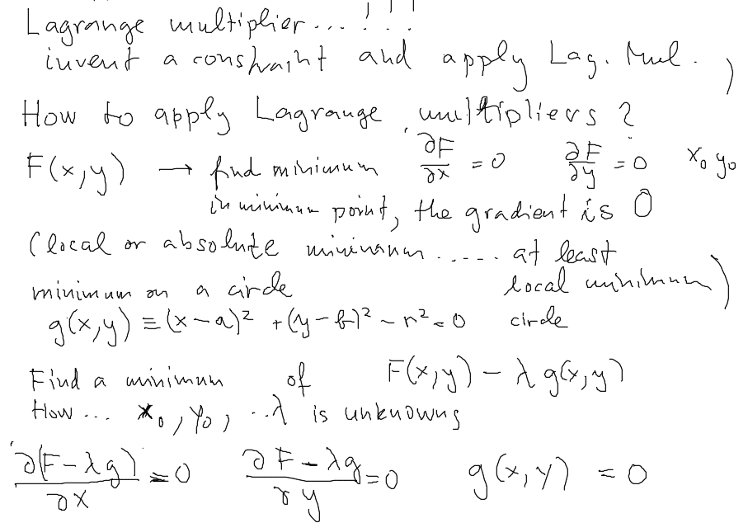
Lagrange Multipliers Part 2 – plane and surface
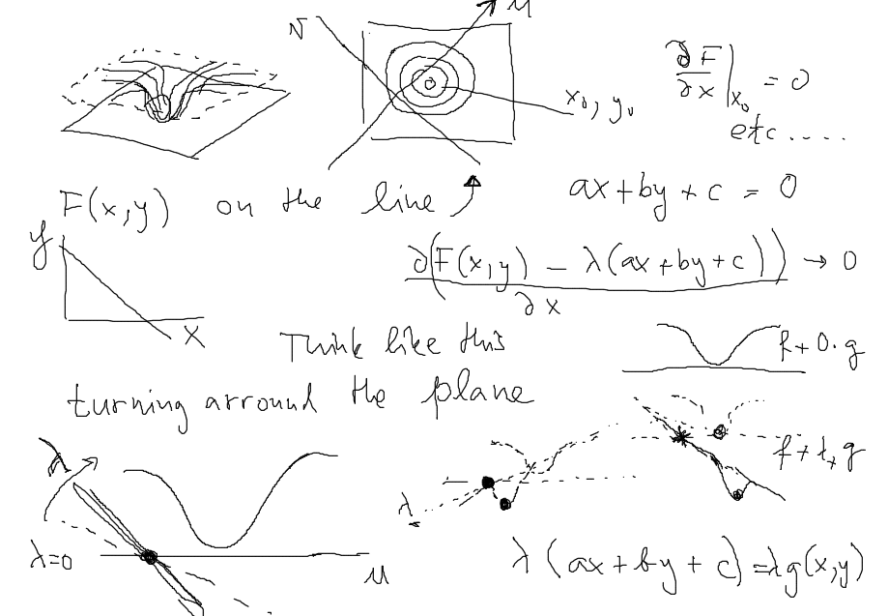
Lagrange Multipliers Part 3
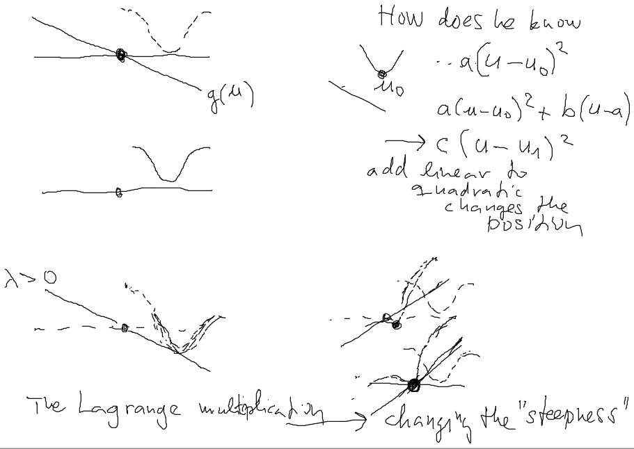
Now we know what to put there:
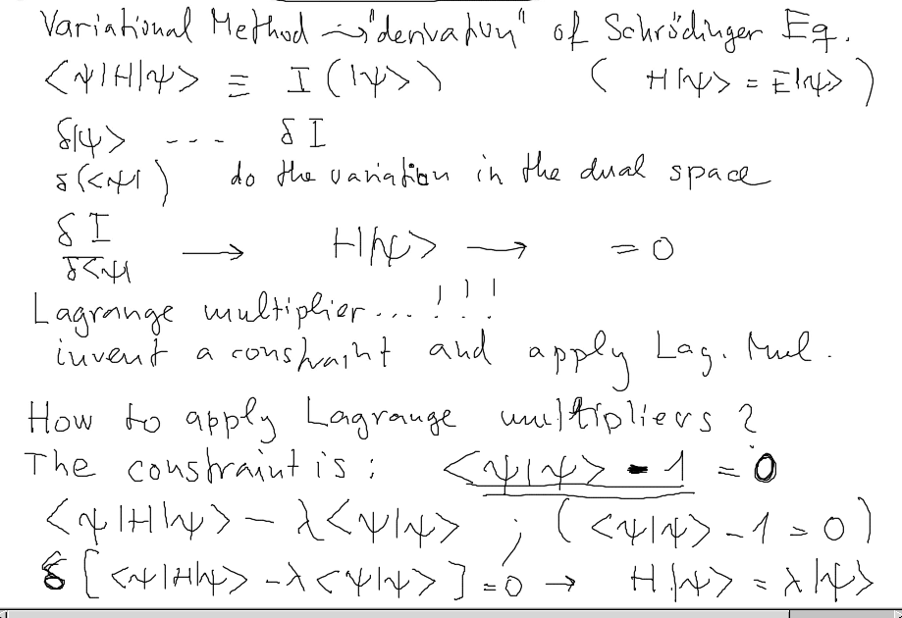
Comment ... the e ^{i α} is an eigenvalue ... αβγδ
And Here we start from Helium energy
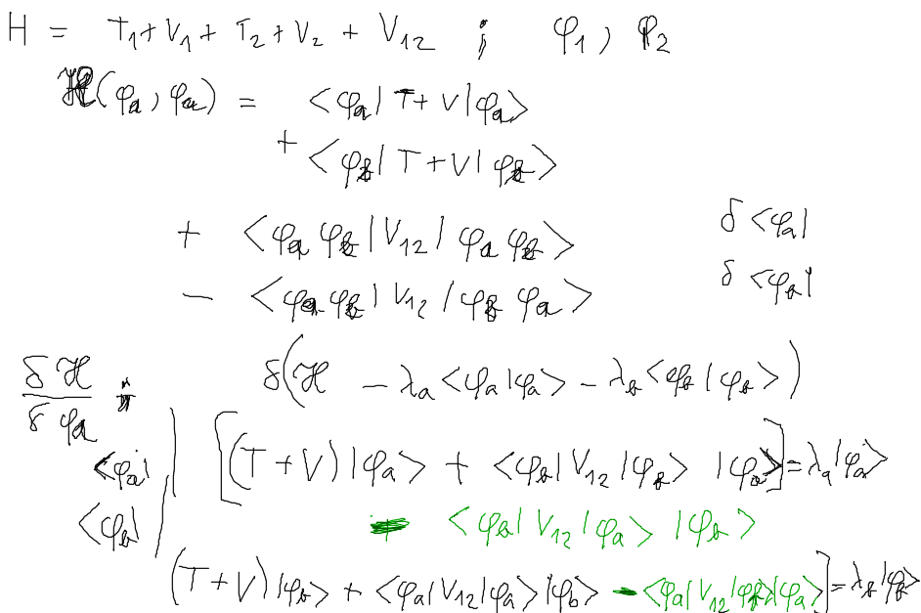

the previous note edited: Helium and variation -> Hartree-Fock equations
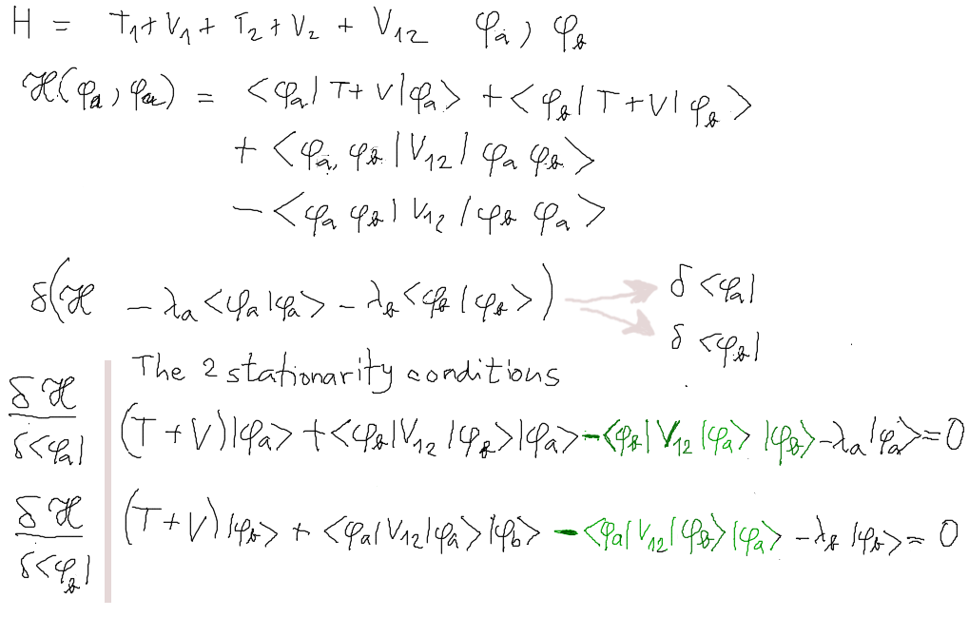
( .... Comment ... the e ^{i α} is an eigenvalue ... αβγλ ...... )
More on Lagrange Multipliers: Minimum of F(x,y) on a curve(line) g(x,y)=0
Here we show g(x,y)=ax+by+c A plot is a plane. We see plot of λg(x,y) for λ=2.2 and λ=0.8 . As we increase λ, we get a steeper plane.
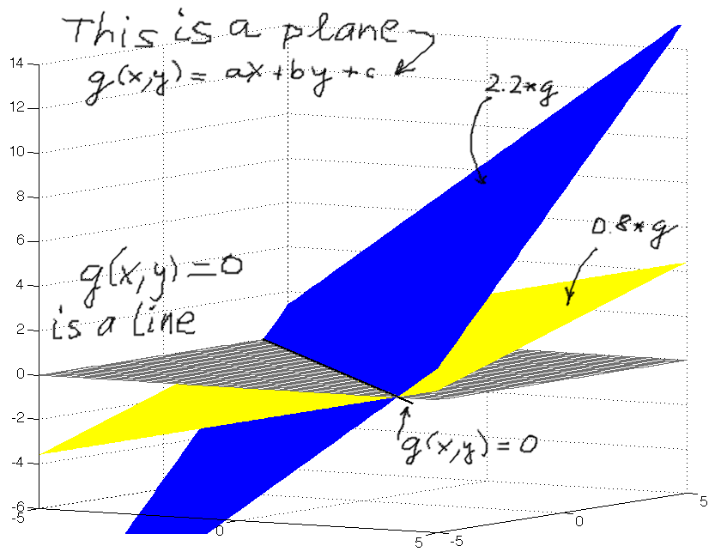
More on Lagrange Multipliers: F(x,y) is here shown – it is a constant mostly with a parabolic hole. The curve(line) g(x,y)=0 is shown, as well as mesh plot of g(x,y). To the left we plot F(x,y) + λg(x,y) for about λ = 1. The point is to vary λ
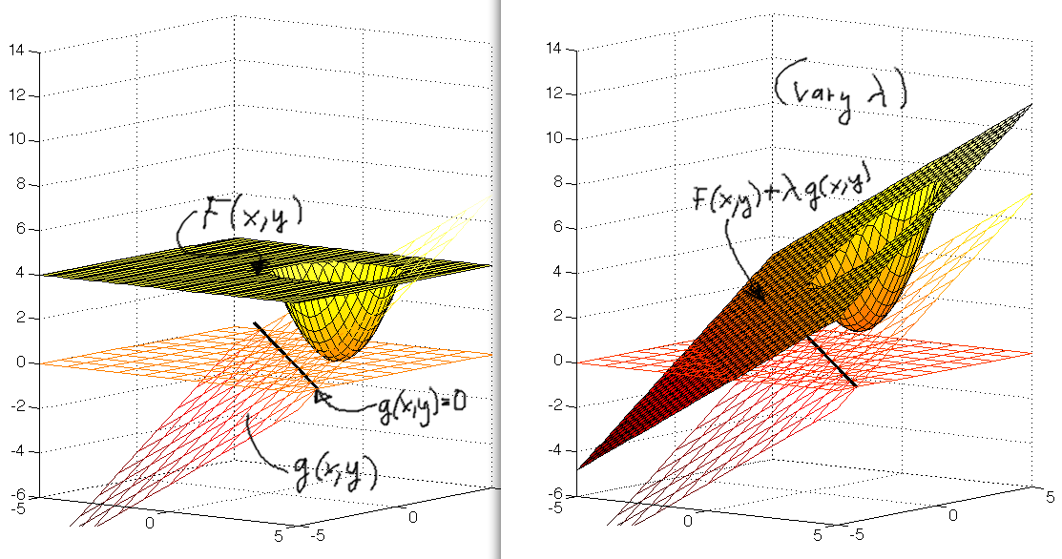

Now we only show cut by a plane. F(x,y) and g(x,y) shown in the left part
with a parabolic hole. The line g(x,y)=0 appearsas a dot To the right we plot F(x,y) + λg(x,y) with the “correct” λ = 1.7. We see that the new function really has a local minimum at (x₀ , y₀ ) lying on the “curve” g(x,y)=0.
Note that since g(x,y)=0, at the minimum, the F(x,y) and the ( F(x,y) + λg(x,y) )
have the same value
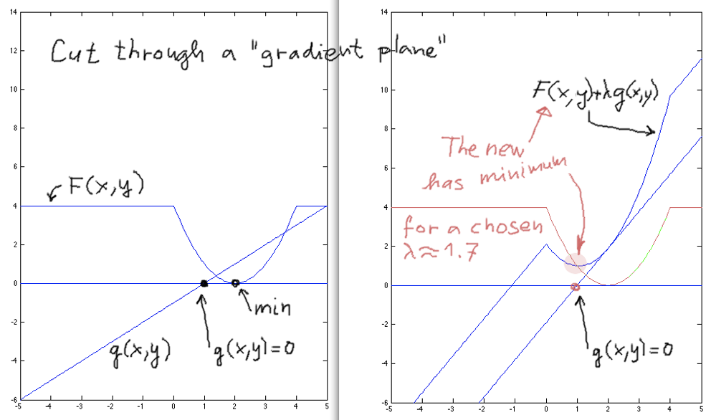
Lagrange Multipliers Summary
Minimum of
F(x,y) on a curve (line) g(x,y)=0

How to: look for minimum of
F(x,y) + λg(x,y) with an unknown λ

The three equations
d/dx ( F(x,y) + λg(x,y) ) = 0
d/dy ( F(x,y) + λg(x,y) ) = 0
g(x,y) = 0

Are solved to give values of x₀ , y₀ and λ
Forget λ , the point(s) (x₀ , y₀ ) give you the desired extremum (minimum, or extrema...)

Why does it work for Schrödinger: Remember the theorem about the minimum for the exact solution.

If the straight line is replaced by a circle – a g(x,y) = x² + y² – r² would be used
etc, etc.... Generalization to 3,4,5 ... N dimensions ....

