Lecture Thursday 27. September 2007
Topics: In lecture: Density Functional Theory Here: Spectroscopy

Comments
Version Tuesday 02. 10. 2007 morning (Final)

Material in Lecture: Kohn' Nobel Lecture; A PDF of talk on DFT (notes will be added)
“Blackboard” - Spectroscopy – and Spectra Terms
Final Question: Why are the TERMS energetically different
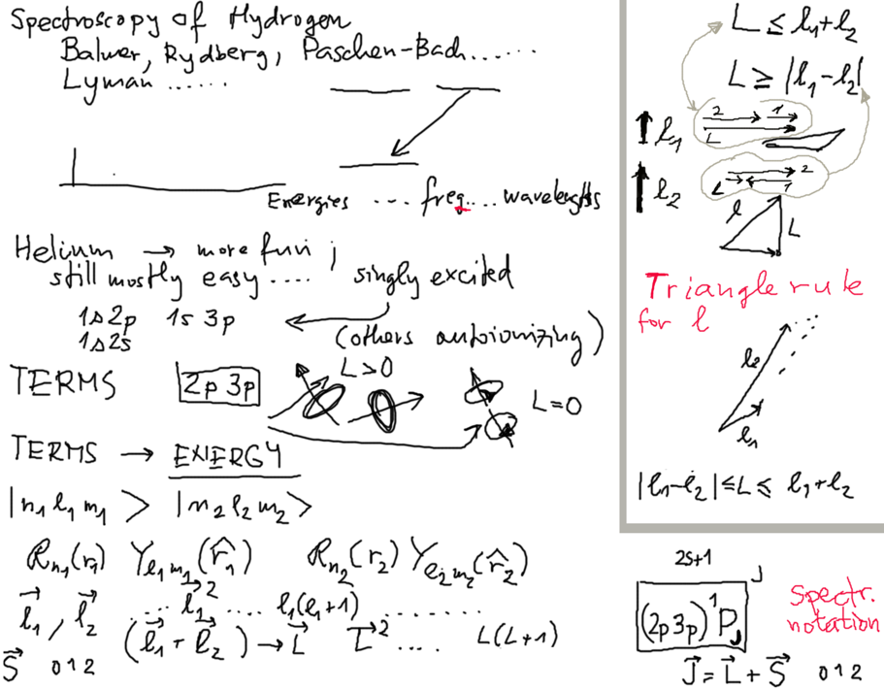

How do we know the Ion. energies?
radiaton / monochromator (prism ? ) Grating (Gitter)
Strong Source Photoelectrons -> Photoelectron spectroscopy

Excited states : Energy emitted - carried as light or El-Mag radiation - only special energies (discrete values) - discrete sets of frequencies (or) wavelengths; Line spectra

SPECTROSCOPY .... for analysis (or proof of presence) ... characteristic lines

spectra continuous -> solid state effects (condensed matter properties) Red glowing hot metal, white metal in a smith's workshop

Spectroscopic terminology ( TERMS )
l₁ l₂ -> L selection rules
each of the L makes a "TERM" example 2p 3p L 0, 1, 2
2p 3p S 2p 3p P 2p 3p D singlet and triplet J- values

Why are the energies different ? The interaction integrals (mentioned in Helium)
Hydrogen – like Helium like - and more complex .... L-S coupling j-j coupling
Config. mixing (NEXT) GTO STO (slaters type orbitals, gaussian type orbitals)
This is the start of java Grotrian at ( He I ) SPECTROSCOPY http://physics.nist.gov/PhysRefData/ASD/lines_form.html
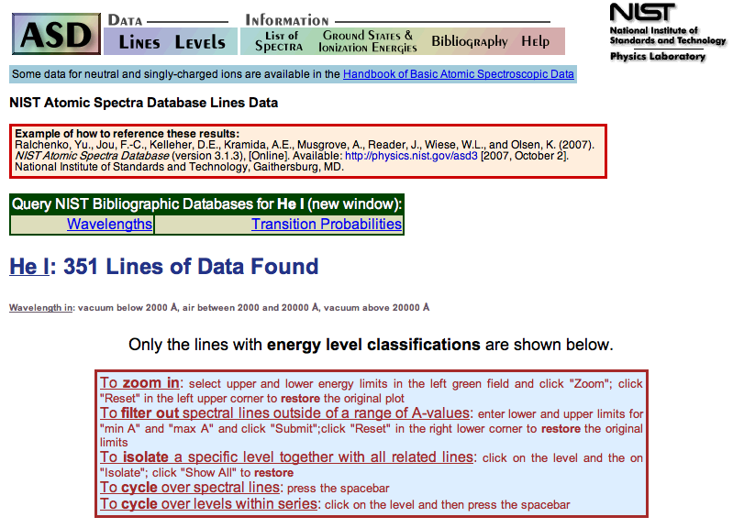
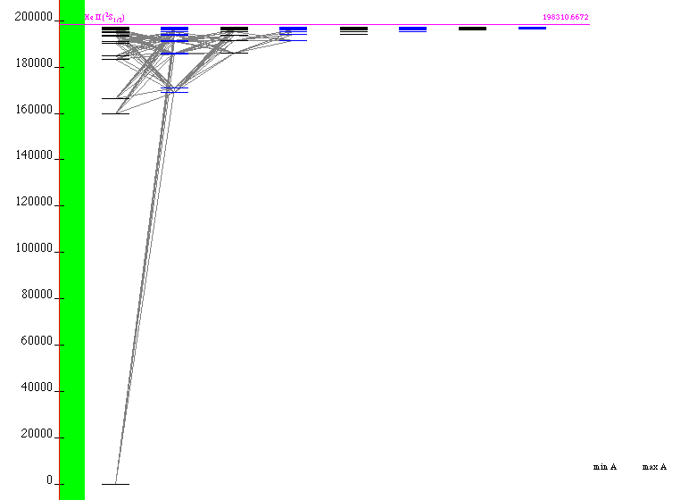
This is the java applet; You can zoom etc. He I (neutral) He II (ionized once)
There is no He III - why? Is there Li III or Li IV, Carbon V ?
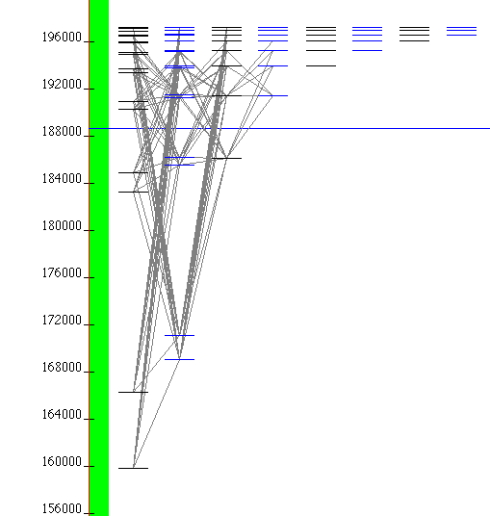
Zooming the upper part of spectrum
The DFT - Density Functional Theory has been discussed on the background of two PDF files: The Nobel Prize Lecture from Review of Modern Physics and a talk from Quantum chemistry (remember – many nuclei in molecules, not just one as in atoms)

Thomas-Fermi model as a sort of basis (electron density)
but built on orbitals; LDA local density approximation
orbitals – selfconsistent field method; Exchange and correlation added by a term.
Prof. Kohn: ... I begin with a provocative statement. In general the many-electron wave function Ψ ( r₁ , . . . , r_{N} ) for a system of N electrons is not a legitimate scientific concept, when N > N₀ , where N₀ is about 1000 .
The article gives a very nice introduction to Molecular Physics, Born-Oppenheimer, etc

More: Thomas Fermi Model and the exchange functional.
Is there a correlation term in full formulation?
From the talk: 

